Software Architecture Document

Product Name:
Project Name:
Project ID: | IBC
Module Name: | N/A
Project Manager: | N/A
IR/P ID: | N/A

Document Version: | 1.0
Release Date: | 28 November 2006

Approval by:
# | Full Name | Position
1
2

Revision History

# | Date | Version | Author | Review | Description/Changes
1
2

Table of Contents

Revision History 2
1. Introduction 4
1.1 Purpose 4
1.2 Scope 4
1.3 Definitions, Acronyms and Abbreviations 4
1.4 References 4
1.5 Overview 4
2. Architectural Representation 5
3. Architectural Goals and Constraints 5
3.1 Architecturally significant requirements 5
3.2 Technical platform 6
3.3 Security 6
3.4 Volume 6
3.5 Persistence 6
3.6 Performance 6
3.7 Internationalization 6
3.8 Technologies used (selected architecture / technical solutions) 6
4. Use-Case View 7
4.1 Introduction 7
4.2 Architecturally Significant Use Cases 7
4.3 Use-Case Realizations 8
5. Logical View 8
5.1 Overview 8
5.2 Architecturally Significant Design Packages 8
6. View 8
7. Deployment View 8
8. Implementation View 8
8.1 Overview 8
8.2 Layers 8
9. Data Views (Optional) 8
10. Size and Performance 8
11. Quality 8

Introduction
International Betting Company (ibc) provides sports book and betting service for all customers over the world that interest with betting any sports such as soccer, basket ball, or tennis in any league. Provide information of each match live or not, allow customer performance transaction thought the internet with the account which creates on IBC. IBC is deployed on web application environment with more than 10 member sites which provide information of sports and allow members bet directly on the website. IBC member sites are implemented by SMS software development team.
Objective of us is development the website which allows 80.000 users concurrent per 1.000.000 end-users who register to create account IBC website.
Software Architecture Document provides an overview about IBC Architecture for people related to IBC project such as Software Architects, Project Team and Test Team. This document is written by Software Architect Team.

1.1 Purpose
This document provides a comprehensive architectural overview of the system, using a number of different architectural views to depict different aspects of the system. It is intended to capture and convey the significant architectural decisions which have been made on the system.
Software Architecture Document shows subsystems description, interfaces of website, layers, packages, and classes to build project. In this document we use the “4 +1” View Model of Software Architecture to describe IBC architecture.

1.2 Scope
Software Architecture Document focuses on 4 views: Logical View, Development View, Process View, and Physical View.

This document will affect on the design and implementation of system in the future.

1.3 Definitions, Acronyms and Abbreviations

1.4 References

1. http://web.cs.wpi.edu/~gpollice/cs4233-a05/rup_sad.html

1.5 Overview
This document includes 11 sections and their subsections
Introduction: Provide an overview the entire Software Architecture Document.
Architectural Representation: Describes architecture of the current system.
Architectural Goals and constraints: describes the software requirements and objectives that impact on the architectural.
Use-Case ViewLogical View: describes the architecturally significant parts of the Process View: describes the system’s decomposition into lightweight processes and heavyweight processes.
Deployment View: Implement View: describers the overall structure of the implementation model, the decomposition of the software into layers and subsystems in the implementation model, and any architecturally significant components.Data View: the persistent data storage perspective of the system
Size and Performance: description of major dimensioning characteristics of the software that impact the architecture.
Quality: the way software architecture contributes to all capabilities of the system.

Architectural Representation

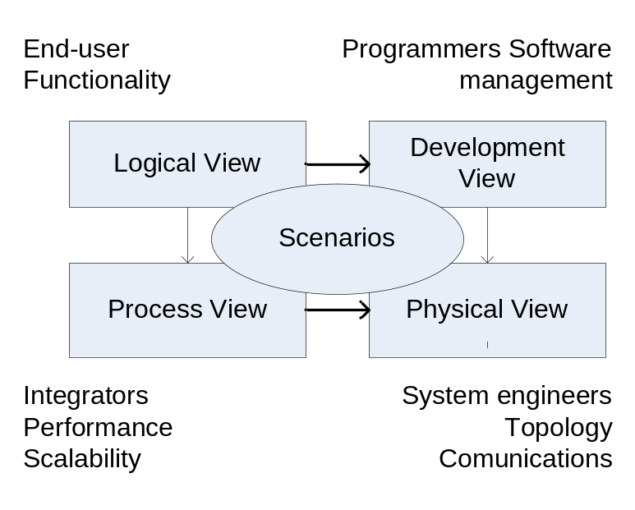
Figure1. The “4 + 1” view model

- Logical View:
- Process View:
- Development View:
- Physical View:
- Scenarios:

Architectural Goals and Constraints

3.1 Architecturally significant requirements
IBC architecturally
- New IBC system should be able to run parallel with IBC current system (ASP).
- Application will be customized to have several interfaces for several sites.
- Deployed on several physical servers.

3.2 Technical platform
- Net framework 2.0
- IIS 6
- Database platform: SQL Sever 2000

3.3 Security
IBC system is deployed with high security.
- Authentication: Users must log in to use the system with accounts that registered.
- Authorization: Depending on rights and permissions which assigned to users, they can access their sites.
  - Members only use member sites
  - Agent, Master, and Super use Agent sites.
  - Admin 2 users use Admin 2 sites.
  - Admin 1 users use Admin 1 sites.
- In the auditing we logged all users’ actions during the time they access sites.
- Confidentially: We use SSL to encrypt sensitive data.
Note: Admin 1 and admin 2 have permission management functionalities to prevent unauthorized actions.

3.4 Volume
IBC Volume allow
- Our object is support 80.000 concurrent online users.
- Build database which can store 1.000.000 end users information.
- Allow perform 3.000.000 transactions per day.

3.5 Persistence
- In IBC system, we use rational database to store data.

3.6 Performance
The performance of system which we want achievement
- The time for member betting functionalities less than 1s.
- Controller/ monitor functionalities less than 1s.
- The time report for user’s request less than 60s.

3.7 Internationalization
IBC system supports multiple languages
- Chinese with simplified and traditional.
- English
- Japanese
- Thai

3.8 Technologies used (selected architecture / technical solutions)
IBC system technologies which requires:
- Windows Sever 2003 operating system.
- SQL Server 2000.
- SSL.
- ASP.Net and JavaScript.
- Development and Test: Visual Studio 2005 Team System.
- Project Management and source code: Visual Studio 2005 Team Foundation Sever.

Use-Case View

Introduction
- Use cases diagrams capture functionalities behavior of the system in order to help people who relate to this project easy to understand the process and architectural of system.
- For more detail information will be shown at use-cases specifications.

4.2 Architecturally Significant Use Cases
The use case general below shows the function of users in the IBC System.
- Members
  - Can register to access the IBC website.
  - Bet any sports which follow the rules of website.
  - Deposit/with draw money
- Agent/ Master/ Super
  - Create downline accounts
  - Transfer money.
  - Monitor risk
- Admin
  - Control odds of each match.
  - Create/manage events for match
  - Create/manage customers such as customer’s information, customer’s transactions.
  - Accept/delete tickets of members.

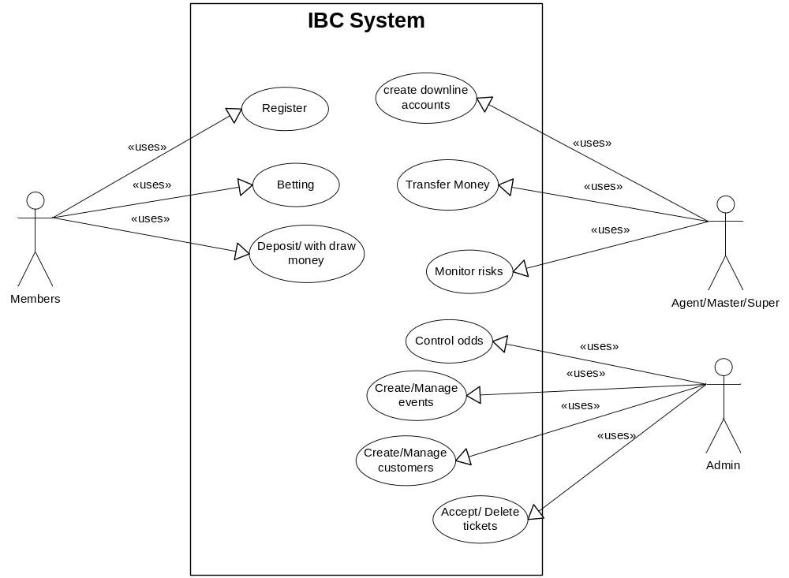

Figure2: IBC System use case

4.3 Use-Case Realizations

Logical View

5.1 Overview

5.2 Architecturally Significant Design Packages
The approval sign off which is presented on cover page can be performed by sign off signature or email and means that the list of persons are agreed upon all detailed of this document.

View

Deployment View

Implementation View

8.1 Overview

8.2 Layers

Data Views (Optional)

Size and Performance

Quality

l

